Plein Air Sketching with Tara Sweeney
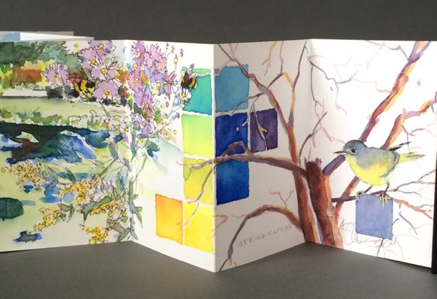

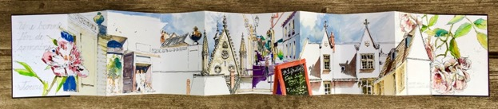

Combine watercolor and ink to sketch on location from direct observation. See where your curiosity can lead you. Improve skills and gain confidence through expert demonstrations, individualized feedback and focused sketching time. Get started on this versatile and portable sketching habit. All skill levels welcome.

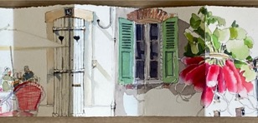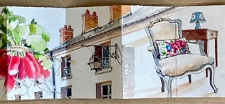
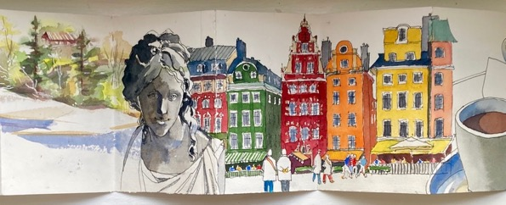

Materials List:
- If you’d like to sketch in a ZigZag sketchbook, choose a hard-cover, accordion-style watercolor sketchbook that folds down from 40 inches fully extended to 4x6 inches (Pentalic Dreamcatcher, Senelier Urban, Hahnemuhle Zigzag are examples) But, any sketchbook format with good quality paper that you enjoy is fine.
- Bring a couple of watercolor postcards, 4x6 inches (Strathmore makes a pack of 15, or cut your own from your favorite watercolor paper)
- A travel set of professional quality, hard pan watercolors: 6-12 colors with a couple of good size mixing areas in the palette lids.
- White permanent ink pen such as Uniball Signo broad gel pen
- Pentel Aquash Large round water brush and a traditional travel watercolor round with a good point, #6-8 sable or synthetic.
- Permanent black ink pen, 0.3-0.5 width (Staedtler permanent fine liner. I demonstrate with a refillable TWSBI mini fountain pen and carbon ink. Check that your pen will make a wash when clear water is added right after making a mark. Then check that it is permanent when completely dry. We’ll use it both ways.
- 2B drawing pencil with sharpener or a mechanical pencil with 2B leads (no H leads please.)
- Kneaded eraser (make sure it’s kneaded, and not just any eraser)
- Fine spray bottle and an 8-16 oz water bottle for refills
- Three-part nesting rinse containers.
- Paper towels or reusable absorbent sponge, chamois or rag
- Rubber band to secure sketchbook in closed position
- 4 binder clips to secure sketchbook in open position
- Waterproof pouch or Ziploc bags to keep sketchbook and wet palette separate
- Small backpack or bag to carry gear
- Optional: portable stool--be sure you can easily carry it in addition to all your other gear
- Optional: portable easel--be sure you can easily carry it in addition to all your other gear
- Plan for weather and walking: comfortable shoes; sun, rain, wind protection; temperature comfort, insect repellent.
- Bring a sense of adventure and a sense of humor.
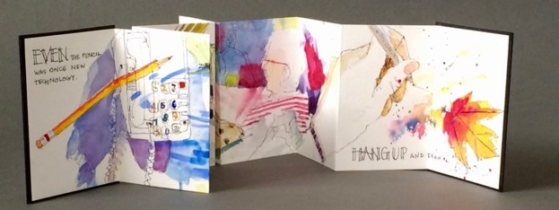

Teaching Philosophy
I have been sketching and painting with watercolor and ink for nearly forty years and I am not yet bored with my favorite water media. I like to think of it as a dance--if I remember to follow watercolor’s lead, the result is fluid, elegant, effortless. If I don’t, we still dance, but it’s awkward. Learning to let the water do the work takes time, practice and good coaching. That’s where I can help.

What kind of sketch are you longing to create? The “right” way to sketch is the way that best supports your ideas and goals (not mine). With four decades of teaching experience I can help you explore what to sketch and how, but just as importantly, why. We’ll explore techniques and design principles to support your goals. When you get stuck—we all do from time to time–I’ll help you find ways to get going again. I’ll check in with you as you sketch to see how it’s going. When you want direction, I’ll be there to help. My demonstrations and warmup exercises are carefully designed to help you make progress and have FUN. I provide handouts and an overview before we start, and a summary on completion.

We’ll start wherever you are in your creative journey. Together we will make art and messes, intentional choices and happy accidents. We will find problems to solve, courage to try, and resilience to continue.

I look forward to learning what you long to create, what might be holding you back, and how I can help you acquire the skills and confidence to bring your best sketches to life. At the end of our time together, I’ll know I’ve succeeded when your work is distinctively yours, (not at all like mine), and you can’t wait to do more wherever life and your art supplies take you next.

Tara

